**Project Design Phase-II**

**Data Flow Diagram & User Stories**

|  |  |
| --- | --- |
| Date | 31st, March 2025 |
| Team ID | SWTID1742493942 |
| Project Name | Connectify - Social Media App |
| Maximum Marks | 4 Marks |

**3.3 Data Flow Diagram (DFD)**

**Context Diagram of Social Networking Application**

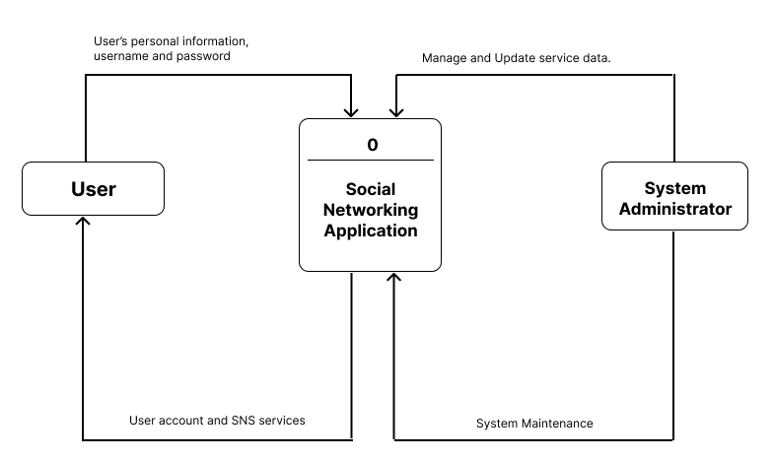

**Data Flow Diagram of Social Networking Application**

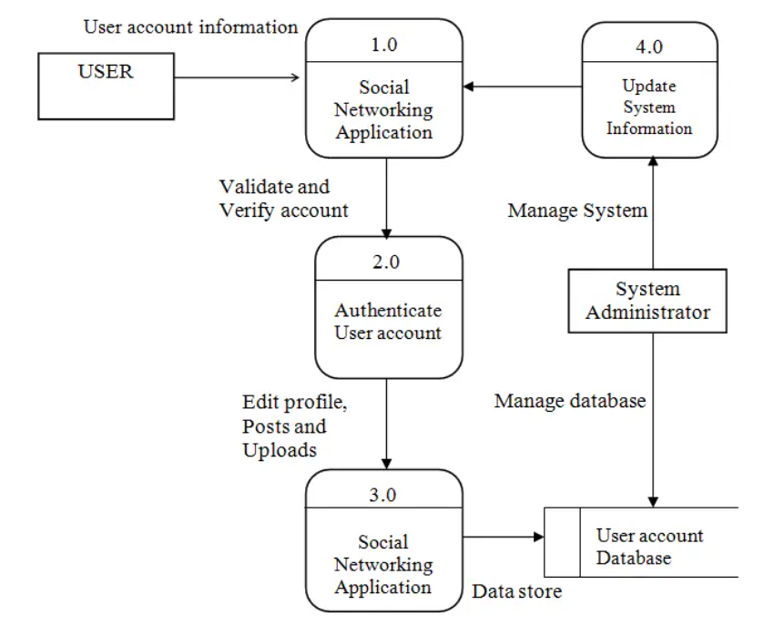

**Data Flow Diagram of Online Registration of Social Networking Application**

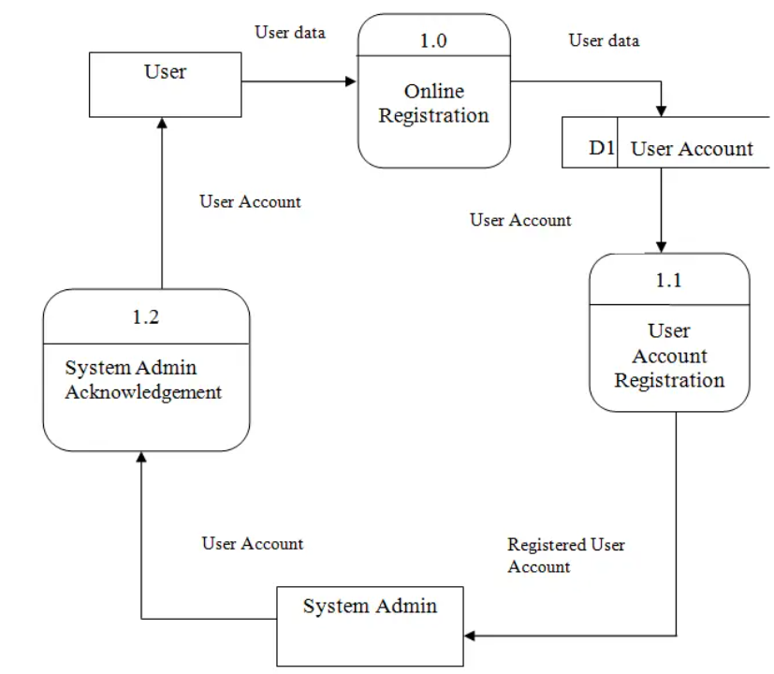

**Data Flow Diagram of Online Services of Social Networking Application**

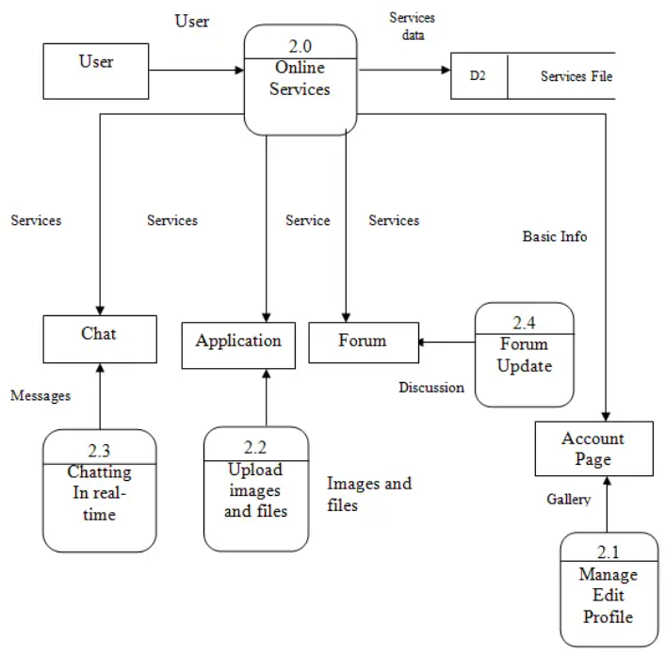

**CUSTOMER JOURNEY MAP**

| **Stage** | **Actions** | **Thoughts** | **Emotions** | **Opportunities** |
| --- | --- | --- | --- | --- |
| **1. Awareness** | - Sees a post/story shared by a friend from the app - Learns about the platform on social media | “This looks different from Instagram or Snapchat.” | Curious, Interested | Use relatable marketing & highlight unique features (reminders, personal feed) |
| **2. Onboarding** | - Downloads the app - Signs up and creates profile - Uploads profile pic & adds bio | “Setting this up is easy!” “I hope I can make my profile feel *me*.” | Excited, Motivated | Keep onboarding smooth and add profile-building tips/suggestions |
| **3. Exploration** | - Scrolls through home feed - Sees post cards, birthday cards, suggestions - Clicks on reminders | “Nice layout. Not too cluttered.” “Oh, I can even set reminders?” | Impressed, Curious | Highlight key features like birthday reminders and content suggestions |
| **4. Engagement** | - Posts a story or a photo - Comments on a friend’s post - Sets a birthday reminder for a friend | “This is fun.” “Feels more personal than other apps.” | Happy, Engaged | Simplify post/story creation; offer fun tools (stickers, tags, captions) |
| **5. Socialization** | - Receives likes/comments - Gets a reminder about a friend’s birthday - Chats in message section | “Nice, people actually noticed my post!” “Glad I didn’t miss her birthday.” | Connected, Valued | Notifications & in-app alerts should be friendly and real-time |
| **6. Retention** | - Uses reminders weekly - Gets suggestions for new connections - Shares more regularly | “This app fits both my social and daily needs.” | Loyal, Satisfied | Add subtle gamification (like badges or streaks) to keep engagement high |